Setting up workspace
I took a screenshot of my newly created folder (titled ArchOSC Assignment) for lab 2
including a clear showcase of the path to reach said folder and the contents inside.
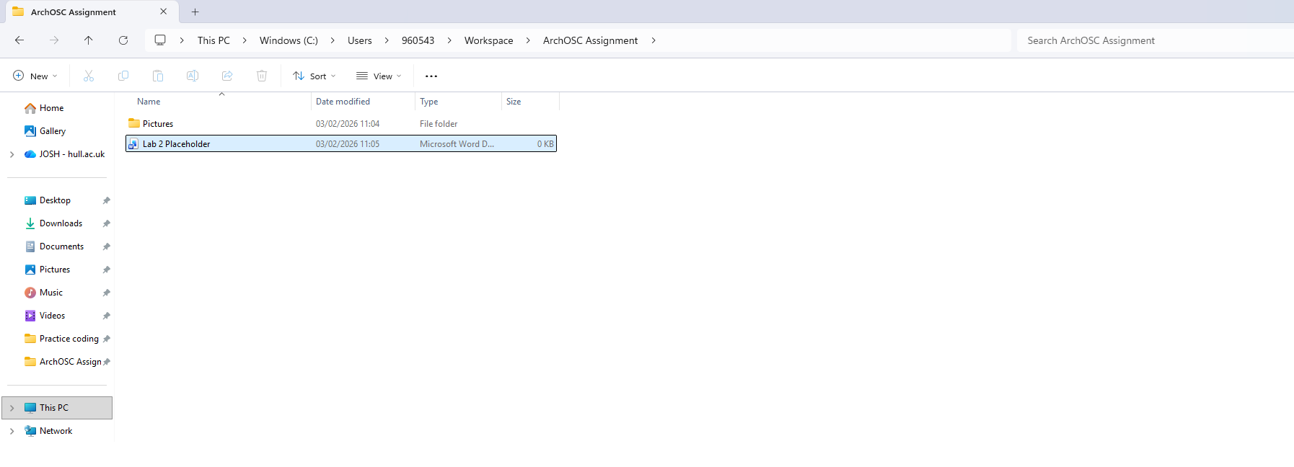

Create local repository
Then I opened my folder within the terminal (directly through folder) before using the
git init command to create a local repository allowing me to edit my work in an
external environment
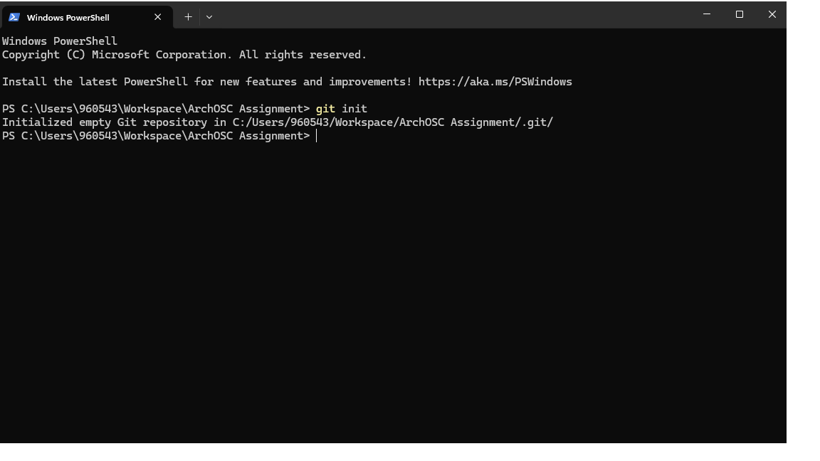

Making GitHub repository
After creating a repository locally, I then had to create a second repository on GitHub
in order to create a place for me to push any edits made locally, following the
restrictions required(added ReadMe and .gitignore)

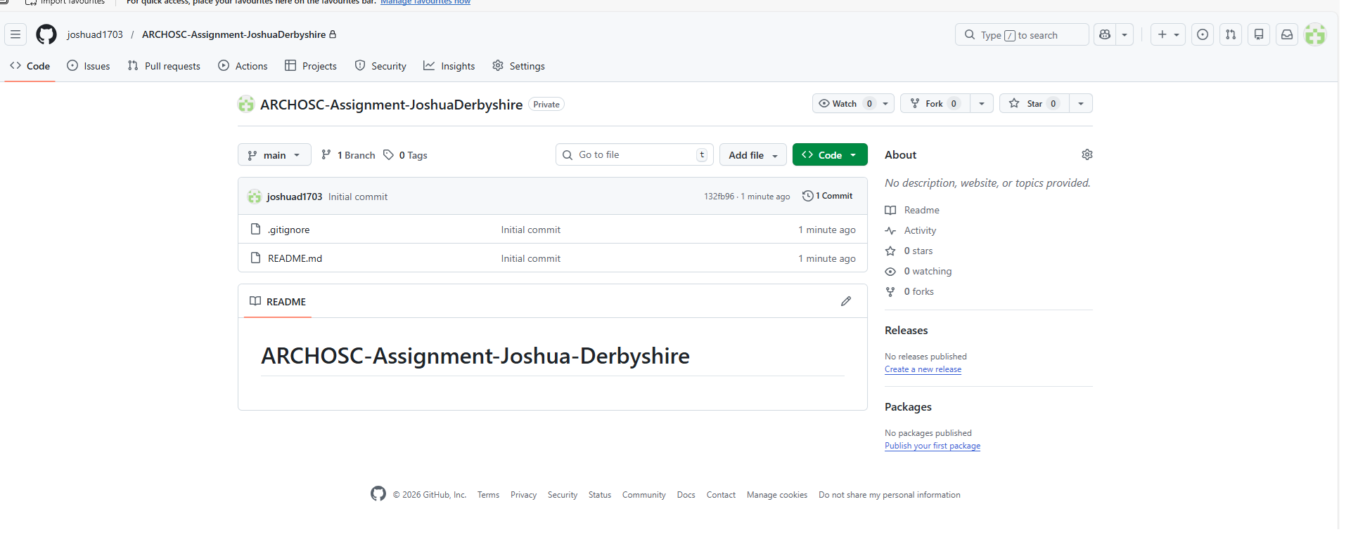

Connecting repositories
Now that I have both repositories, I now must create the link between the 2. In order to this I opened my workspace folder in the terminal and used commands “git remote add origin” and “git pull origin main” to connect the 2 allowing me to copy any changes made on one repository to the other 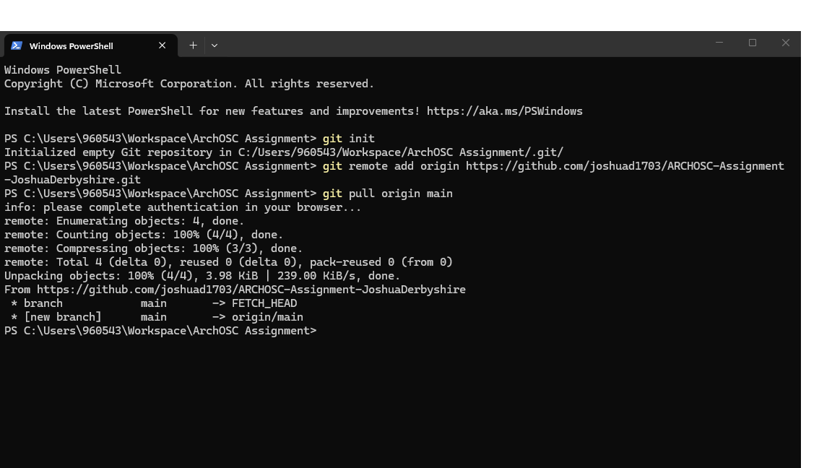

Basic website
Now both repositories are linked I now started my first project, creating a simple website. I did this in visual studio code using the html code provided in the lab work
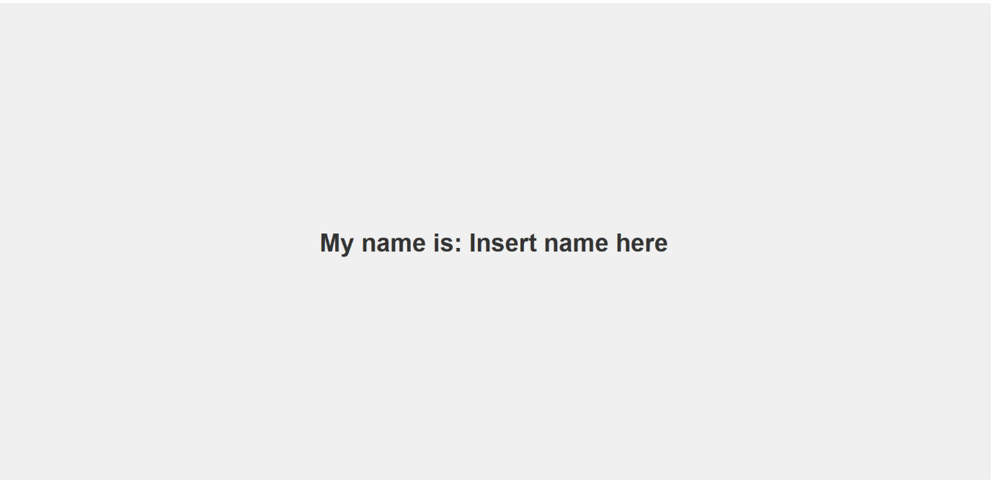

Saving locally
Now this website is done I must first save it to the local repository. I did this using commands “git add .” and “git status” throughout to get a colour coordinated response showing which files are and are not saved .
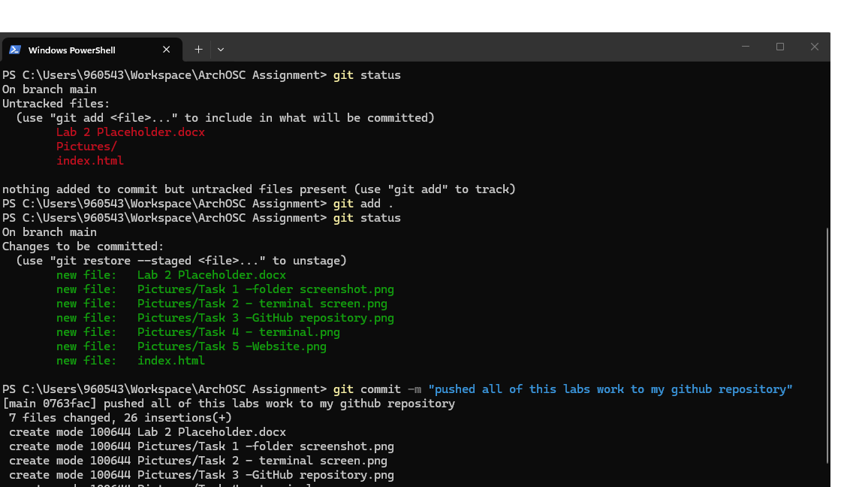

Pushing to GitHub repository 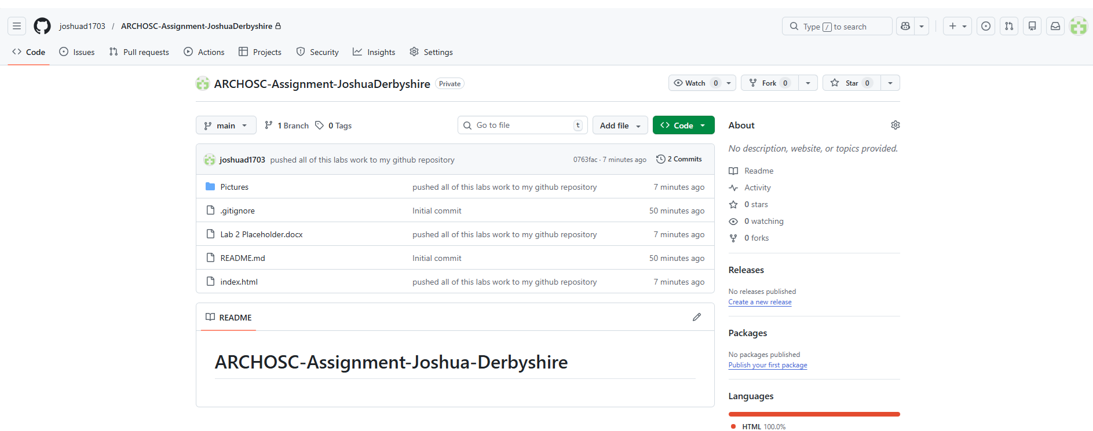
Now that its locally saved I must now push it to my online repository on GitHub. I did this back in terminal using command “git push -u origin main” to push all changes and “git commit -m “….”” To write a brief description of what changes have been made

Website changes and pushing to GitHub
Finally, I now made 2 edits to my original website before repeating the process to push these edits to my GitHub repository.

Edit 1
Changed the text from “Insert name here” simply to my name by editing the text within the <h1> tag
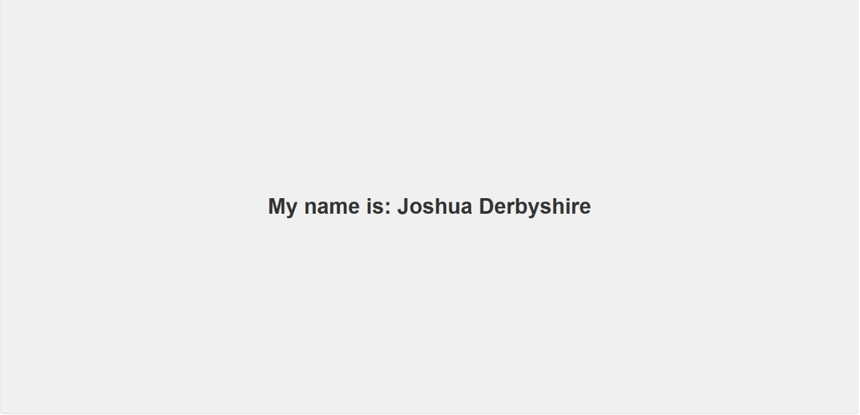

Edit 2
Changed the background colour from white to red to make it visually brighter by editing line “background-color:..…”
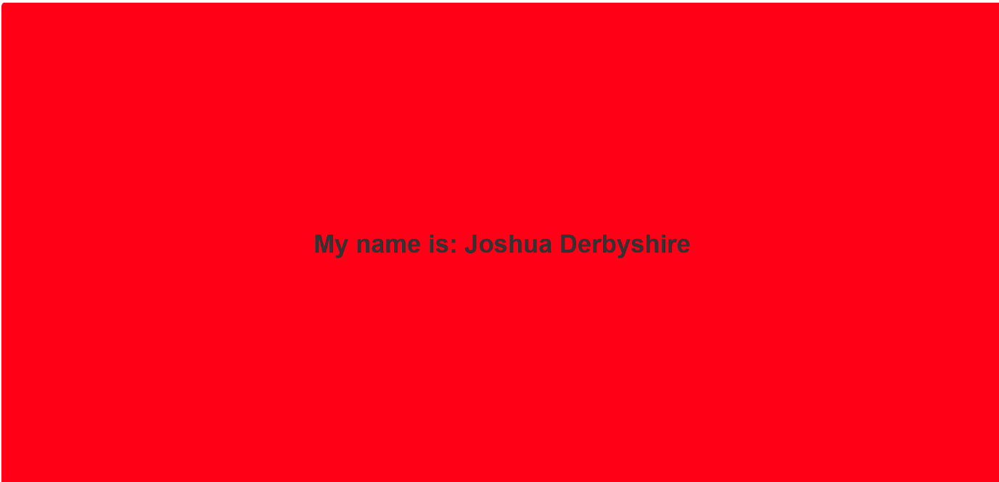

Edits pushed to GitHub
